Isotopes
Atoms and elements are made of protons, neutrons and electrons. The nucleus is made of protons and neutrons, and the electrons surround the nucleus, as shown in the illustration below. The sum of the number of protons and the number of neutrons is equal to the atomic mass.
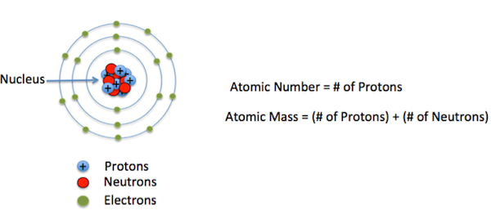
In a given element, the number of neutrons can be different from each other, while the number of protons is not. These different versions of the same element are called isotopes.
Isotopes are atoms with the same number of protons but that have a different number of neutrons. Since the atomic number is equal to the number of protons and the atomic mass is the sum of protons and neutrons, we can also say that isotopes are elements with the same atomic number but different mass numbers.
Isotopes of Hydrogen
The three are all isotopes of hydrogen. As you can see, they have the same atomic number, or number of protons, (number at the lower left of the element) but different atomic masses (number at the upper left of the element).
The number of neutrons can be calculated by calculating the difference between the atomic mass and atomic number. We can see that for the isotopes of hydrogen, they have varying number of neutrons. For protium, the number of neutrons is zero, for deuterium, the number of neutrons is one, and for tritium, the number of neutrons is two.
Going back to our comparison with identical twins, we can say that these three isotopes of hydrogen are like identical triplets of each other - they may appear to be identical outside, but they are different inside, and they also have different names.

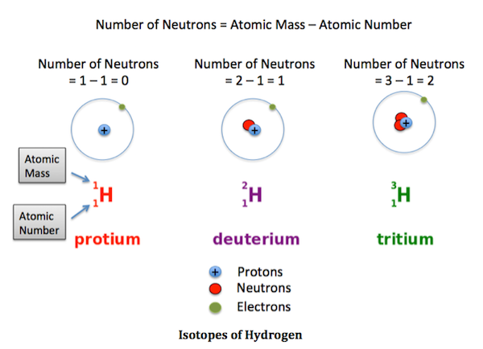

Types of Isotopes
There are two main types of isotopes and these are radioactive isotopes and stable isotopes. Stable isotopes have a stable combination of protons and neutrons, so they have stable nuclei and do not undergo decay. These isotopes do not pose dangerous effects to living things, like radioactive isotopes.
They are typically useful when performing experiments in the environment and in the field of geochemistry. These isotopes can help determine the chemical composition and age of minerals and other geologic objects. Some examples of stable isotopes are isotopes of carbon, potassium, calcium and vanadium.
Radioactive isotopes have an unstable combination of protons and neutrons, so they have unstable nuclei. Because these isotopes are unstable, they undergo decay, and in the process can emit alpha, beta and gamma rays. Radioactive isotope or radioisotope, natural or artificially created isotope of a chemical element having an unstable nucleus that decays, emitting alpha, beta, or gamma rays until stability is reached. The stable end product is a nonradioactive isotope of another element, i.e., radium-226 decays finally to lead-206.

There are about 339 naturally occurring nuclides on Earth,^{[3]} of which 288 are primordial nuclides, meaning that they have existed since the solar system's formation. Primordial nuclides include 34 nuclides with very long half-lives (over 80 million years) and 254 that are formally considered as "stable nuclides",^{[3]} since they have not been observed to decay.
The three are all isotopes of hydrogen. As you can see, they have the same atomic number, or number of protons, (number at the lower left of the element) but different atomic masses (number at the upper left of the element).
The number of neutrons can be calculated by calculating the difference between the atomic mass and atomic number. We can see that for the isotopes of hydrogen, they have varying number of neutrons. For protium, the number of neutrons is zero, for deuterium, the number of neutrons is one, and for tritium, the number of neutrons is two.
Going back to our comparison with identical twins, we can say that these three isotopes of hydrogen are like identical triplets of each other - they may appear to be identical outside, but they are different inside, and they also have different names.

Application of Radioisotopes in Biology
Radioactive isotopes have a variety of applications as they are useful as the radioactivity of these isotopes can be detected or the energy released by them can be used. Radioisotopes are effective traces as their radioactivity is easy to detect. Tracers can be used to detect leaks in underground water pipes; also they can be used to follow steps of a complex chemical reaction.

A good example of uses of radioisotopes in biology is using the carbon-14 isotopes in determining the steps in the process of photosynthesis in plants. Other use of radioisotope is for establishing age of various objects.

Radiations that are emitted by some radioactive substances can be used to kill microorganisms in foodstuffs which enable to prolong the shelf life of these products. Agricultural produce like tomatoes sprouts, mushrooms and berries are irradiated with emissions from radioisotopes like cobalt-60 or cesium-137. The process of irradiation kills a lot of bacteria that can cause spoilage of food. Radioactive isotopes are used in various medical applications. They are used in diagnosing and treating illness and diseases.

Radioisotopes in biology have numerous applications. Radioisotopes have extensive application in molecular biology. Radioisotopes can be incorporated into DNA, RNA and protein molecules both in vivo and in vitro conditions. The molecules of interest or the metabolic pathway can be traced or investigated.

Applications of Radioisotopes in Biology
Isotopes in biology are used in the following manner:
- Used in Urea breath test, it performed to detect the presence of Helicobacter pylori in the stomach. The isotope used here is carbon-14, and is also used in determination of hormone concentration in the plasma and in radioimmunoassay techniques.
- Calcium-47 isotopes are important to biomedical research. It aids in studying the cellular functions of formation of bone sin mammals.
- Carbon-14 is a major research tool. It helps to the testing the potentiality of new drugs whether it is metabolized without formation of harmful byproducts. It is also used in biological research, pollution control, agriculture and archeology.
- Cesium-137 is a radioisotope used in the treatment of cancerous tumors. Also it is used to measure the correct dosages of radioactive pharmaceuticals given to patients. It also used to maintain the right level for food, drugs packaging.
- Chromium-51 is used in the studies of red blood cell survival.
- Cobalt-57 is used a tracer; it is used to diagnose pernicious anemia.
- Cobalt-60 is used in sterilization of surgical instruments. It is also used in treatment of cancer, irradiation of food products.
- Copper-67 helps to destroy the cancer tumor when it is injected with monoclonal antibodies.
- Gallium-67 is used in medical diagnosis.
- Idonie-123 is widely used in the diagnosis of thyroid disorder and diagnosis of disorders of metabolism including functions of brain.
- Iodine-129 is used in in-vitro diagnostic laboratories.
- Iodine-131 isotope is used in treatment of thyroid disorders like Grave's disease.
- An isotope of iron - iron-55 is used in metabolism research.
- Phosphorus-32 is used in the research concerning molecular biology and genetics.
- Selenium-75 is used in studies of proteins in life sciences research.
- Strontium-85 is used in the study of formation of bone and metabolism.
- Sulphur-35 is used in the studies of genetics and molecular biology.
- Technetium-99m is used in blood flow studies and also different chemical forms of this isotope are used for kidney, liver, spleen, bone and brain imaging.
- Xenon-133 is used in nuclear medicinal studies for lung ventilation and blood flow studies.

Geiger Muller Counter
In 1908 Hans Geiger, under the supervision of Ernest Rutherford at the Victoria University of Manchester (now the University of Manchester), developed an experimental technique for detecting alpha particles that would later be used in the Geiger-Müller tube.^{[5]} This early counter was only capable of detecting alpha particles and was part of a larger experimental apparatus. The fundamental ionization mechanism used was discovered by John Sealy Townsend by his work between 1897 and 1901,^{[6]} and is known as the Townsend discharge, which is the ionization of molecules by ion impact.
A Geiger counter consists of a Geiger-Müller tube, the sensing element which detects the radiation, and the processing electronics, which displays the result. The Geiger-Müller tube is filled with an inert gas such as helium, neon, or argon at low pressure, to which a high voltage is applied. The tube briefly conducts electrical charge when a particle or photon of incident radiation makes the gas conductive by ionization. The ionization is considerably amplified within the tube by the Townsend Discharge effect to produce an easily measured detection pulse, which is fed to the processing and display electronics. This large pulse from the tube makes the G-M counter relatively cheap to manufacture, as the subsequent electronics is greatly simplified.^{[2]} The electronics also generates the high voltage, typically 400–600 volts that has to be applied to the Geiger-Müller tube to enable its operation. The article on the Geiger–Müller tube has a more detailed description of the fundamental ionization mechanism.

